Problem Statement
A college timetable lists many classes. Each class has a course name, a day, a start time, an end time and a room. If two classes overlap in time, or two classes need the same room at the same time, the timetable has a conflict. Checking this by hand is slow and error-prone.
Objectives
- Represent a class schedule using tuples and strings.
- Convert time strings to numbers so they can be compared.
- Detect overlapping periods on the same day.
- Find room conflicts (same room, overlapping time).
- List rooms that are unavailable in a given slot.
- Validate a timetable and report clear error messages.

Assumptions
- Each class is a tuple: (course, day, start, end, room).
- Time is in 24-hour "HH:MM" format, e.g. "14:30".
- Valid days are Mon to Sat.
- A class lies within one day (no class crosses midnight).
- Back-to-back classes (one ends 10:00, next starts 10:00) are not a conflict.
- Two classes in different rooms at the same time are allowed, and the timetable is invalid only if the same room is double-booked.
- The list of valid rooms is given.

Algorithm
- Convert each "HH:MM" string into minutes since midnight (09:30 becomes 570).
- Two periods overlap if start1 < end2 and start2 < end1.
- Find overlaps: compare every pair of classes. If the days are the same and the periods overlap, store the pair.
- Room conflicts: from the overlapping pairs, keep those with the same room.
- Unavailable rooms: for a requested day and time, collect the rooms of all classes whose period overlaps it.
- Validate: for each class check the format, day, start < end, and room exists. If there are no errors so far, also check for room conflicts. Valid means the error list is empty.
Pseudocode
FUNCTION time_to_minutes(t):
split t into hours and minutes
RETURN hours * 60 + minutes

FUNCTION is_overlap(s1, e1, s2, e2):
RETURN s1 < e2 AND s2 < e1

FUNCTION find_overlaps(timetable):
result = empty list
FOR i = 0 TO n-1:
FOR j = i+1 TO n-1:
IF day[i] == day[j] AND is_overlap(times of i, times of j):
add (class i, class j) to result
RETURN result

FUNCTION find_room_conflicts(timetable):
RETURN pairs from find_overlaps WHERE room1 == room2

FUNCTION unavailable_rooms(timetable, day, start, end):
busy = empty set
FOR each class in timetable:
IF class.day == day AND is_overlap(start, end, class.start, class.end):
add class.room to busy
RETURN busy

FUNCTION validate_timetable(timetable, rooms):
errors = empty list
FOR each class:
check format, day, start < end, room in rooms
add a message to errors for every problem
IF errors is empty:
FOR each room conflict: add message to errors
RETURN (errors is empty, errors)
Test Cases
# | Test | Input | Expected result
1 | Partial overlap | 09:00-10:00 vs 09:30-11:00 | Overlap = True
2 | Back-to-back classes | 09:00-10:00 vs 10:00-11:00 | Overlap = False
3 | Overlap by 1 minute | 09:00-10:00 vs 09:59-11:00 | Overlap = True
4 | Same time, different days | Mon 09:00 vs Tue 09:00 | No overlap
5 | Same time, same room | Maths & Physics in R101 | Room conflict found
6 | Same time, different rooms | Maths (R101) & Chem (Lab1) | Overlap, but no room conflict
7 | Busy rooms Mon 09:00-10:00 | Sample timetable | ['Lab1', 'R101']
8 | Free slot | Mon 11:00-12:00 | Empty set
9 | Valid timetable | Maths 9-10, Physics 10-11 in R101 | (True, [])
10 | Bad data | ("X","Sun","10:00","09:00","R999") | Invalid day, bad time order, unknown room
Output
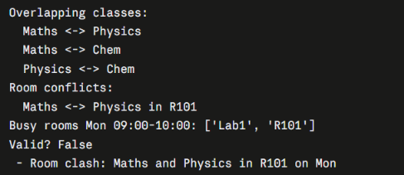
Flowchart
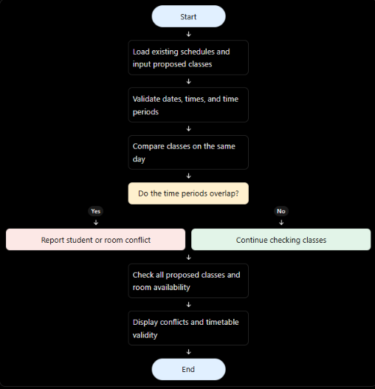
Conclusion
The program takes a timetable stored as tuples and strings and finds overlapping periods, room clashes and busy rooms, then validates the whole timetable with clear error messages. Converting times to minutes makes the comparison simple, and the rule start1 < end2 and start2 < end1 correctly handles partial overlaps and back-to-back classes.

